SIMATS ENGINEERING
ASSESSMENT TOOL 1
COURSE NAME: Computer Vision with OpenCV COURSE CODE: DSA0202
COURSE OUTCOME COVERED
CO2: Apply image processing and feature extraction techniques, including edge detection, motion estimation, and optical flow, for analyzing images.. (BL3)
Assessment Tool Weightage: 50%
QUESTIONS: 5 Total Marks:50 Annexure A
Analytical Problem Solving
Code of Conduct:
I JAASIEL J.S (192524046)_ (Name / Reg No) certify that this submission is my original work and that I have adhered to the guidelines specified for this assessment.
I understand that any violation of academic integrity rules will result in disciplinary action. Signature of the student:
RUBRICS FOR CALCULATION
Numerical Problems
Criteria | Weightage | Level 4 (Exemplary) | Level 3 (Proficient) | Level 2  (Developing) | Level 1  (Beginning) | Marks
Problem  Understand ing | 20% | Clearly interprets  problem, identifies all parameters and  requirements accurately | Understands  problem with minor gaps | Partial  understanding;  misses key elements | Misinterprets or unable to  understand  problem
Method  Selection | 20% | Selects most appropriate method/formula with strong justification | Selects correct  method with minor errors | Inappropriate or  partially correct  method | Unable to select method
Solution  Process | 25% | Logical, systematic steps with correct approach throughout | Mostly correct steps with minor mistakes | Disorganized steps; multiple errors | No clear process
Accuracy  of  Calculation | 20% | All calculations accurate; correct final answer | Minor calculation errors | Frequent errors;  incorrect final  answer | No valid  calculations
Interpretati  on of  Results | 15% | Clearly interprets results with units and  engineering relevance | Basic interpretation with minor  omissions | Limited or unclear interpretation | No  interpretation

Annexure A
Analytical Problem Solving
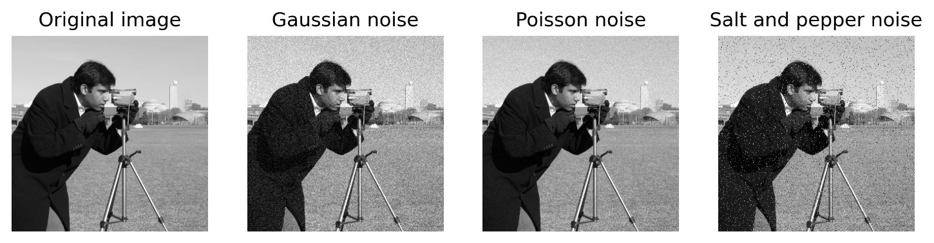
Question 1: Salt-and-Pepper Noise Removal Before Edge Detection
Figure 1: Original grayscale image affected by salt-and-pepper noise, where random pixels become black (0) or white (255).
- Identify the most suitable filtering technique for removing salt-and-pepper noise without causing significant edge blurring.
Ans: The best filtering technique is the 3x3 Median Filter.
- Salt-and-pepper noise changes some pixels to 0 (black) or 255 (white). A median filter replaces the noisy pixel with the middle value of its neighbouring pixels, so it removes noise without affecting the actual edges.

B. Explain why the selected filter performs better than an averaging filter for impulse noise removal.

Ans:

- The median filter is better than the averaging filter because the averaging filter calculates the average of neighbouring pixels. Because noisy pixels have extreme values (0 or 255), they affect the average and make the image blurred.

- And importantly the median filter does not use the average. It sorts the pixel values and chooses the middle value, so the noisy pixels usually do not influence the result.
- Hence, the Median Filter is more suitable for salt-and-pepper noise removal.

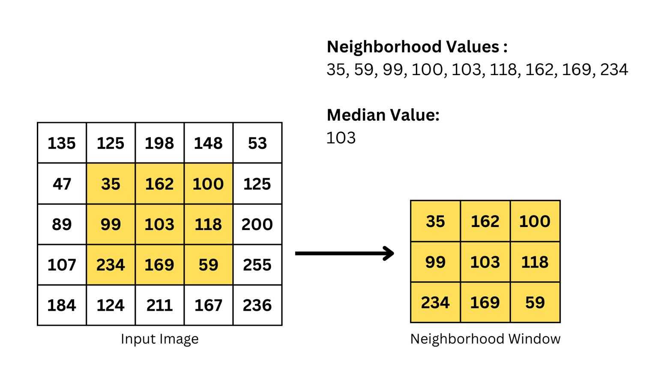

C. If a 3 × 3 median filter is applied, estimate the probability that a noisy center pixel will be corrected. Clearly state your assumptions.

Ans:
Some of the Assumptions are:
- Noise is randomly distributed.
- Probability of a pixel being noisy = 0.05
- Probability of a pixel being clean = 0.95
- A 3 × 3 window contains 9 pixels.

For the median to be correct, the majority of pixels should be clean.
Expected number of clean pixels:
$$9×0.95=8.55$$
Since 8.55 is much greater than 5, the median is almost always taken from a clean pixel.
$$P\left(\text{correction}\right)≈0.99$$
Estimated probability = 99%

D. Estimate the total number of noisy pixels present in the original image.

Ans : Total pixels in the image:

$$1024×1024=1,048,576$$
Noise density = 5%
$$1,048,576×0.05=52,428.8$$
$$\boxed{52,429\text{ noisy pixels}}$$

e. Estimate the expected number of noisy pixels remaining after median filtering.

Ans: Assuming the median filter removes 99% of noisy pixels:
$$52,429×0.01=524.29$$
$$\boxed{≈524\text{ pixels remain noisy}}$$
This means most of the noise is removed before edge detection.

F. Explain how the preprocessing strategy would change if the same image was affected by Gaussian noise instead of salt-and-pepper noise.

Ans: If the image contains Gaussian noise, the preprocessing method changes completely.
- Gaussian noise affects almost every pixel with small random variations.
- A Median Filter is not the best choice.
- The preferred method is a Gaussian Filter.

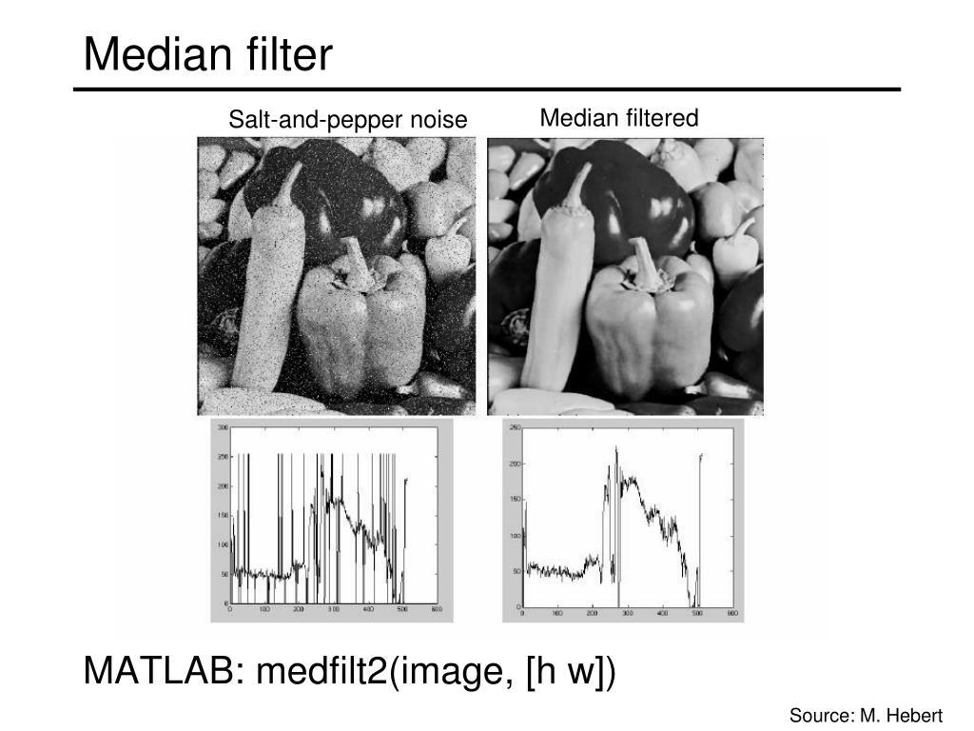
Figure 3: Comparison of edge detection before and after median filtering. Noise removal improves edge clarity and reduces false edge detection.
Question 2: Discretization of a Continuous Image
Given Data
- Image type : Analog Grayscale Image
- Intensity variation : Smooth sinusoidal variation along the x-direction
- Intensity along y-direction : Constant
- Spatial range : 0 to 255 in both x and y directions
- Objective : Convert the analog image into a digital image.

- Explain how the continuous image can be converted into a digital image using sampling and quantization.

Ans: An analog image contains continuous intensity values and cannot be processed directly by a computer. Therefore, it must first be converted into a digital image. This conversion involves two important steps: Sampling and Quantization.

Step 1: Sampling

Sampling converts the continuous spatial coordinates into discrete pixel locations.
- The image is divided into a grid.
- Each grid point becomes one pixel.
- Higher sampling produces more pixels and better spatial detail.

Step 2: Quantization

After sampling, each pixel still has a continuous intensity value.
Quantization converts these continuous intensity values into a fixed number of digital levels.

For an 8-bit image, every pixel intensity is stored between:
0 (Black) → 255 (White)
Thus, the analog image becomes a digital image that can be stored and processed by a computer

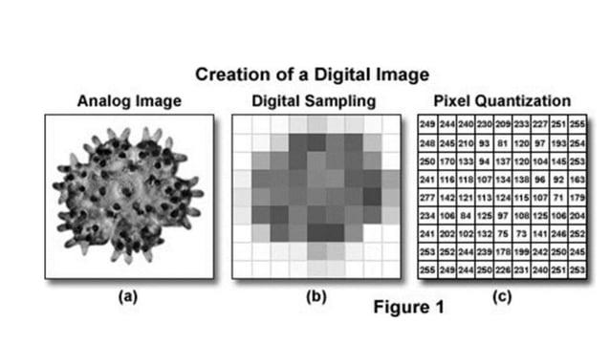
Figure 1: Conversion of an analog image into a digital image using sampling and quantization.

B. Identify the spatial variation pattern of the image in the x-direction. c. Determine the minimum sampling requirement needed to avoid aliasing in the x direction.

Ans: The image intensity varies as a sinusoidal wave along the horizontal (x) direction.
This means:
- The brightness increases smoothly.
- It reaches a maximum value.
- Then decreases smoothly.
- This pattern repeats periodically.
Since there is no variation along the y-direction, every row of the image has the same intensity pattern.
Therefore,
Spatial variation = Periodic Sinusoidal Pattern along the x-axis.

C. Determine the minimum sampling requirement needed to avoid aliasing in the x-direction.

Ans: To avoid aliasing, the sampling frequency must satisfy the Nyquist Sampling Theorem.
According to the theorem,
The sampling frequency must be at least twice the highest spatial frequency present in the image.
Mathematically,
$$f_{s}≥2f_{max}$$
where:
- $f_{s}$= Sampling frequency
- $f_{max}$= Highest spatial frequency of the sinusoidal image
Therefore,
Minimum Sampling Rate = 2 × Highest Spatial Frequency
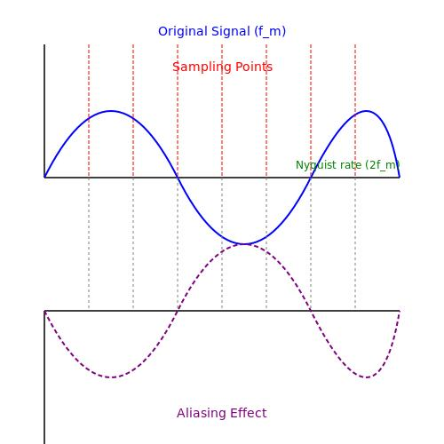
This ensures that the sinusoidal intensity variation is represented accurately without distortion.

Figure 2: Illustration of correct sampling and aliasing based on the Nyquist sampling theorem.

D. Explain what will happen if the image is sampled below the required sampling rate.

Ans:
If the sampling frequency is less than the Nyquist rate, aliasing occurs.
Aliasing causes the digital image to represent incorrect intensity patterns.
The effects include:
- False image patterns
- Distorted sinusoidal waves
- Jagged edges
- Loss of image details
- Incorrect feature extraction
- Reduced edge detection accuracy
Therefore, sampling below the required rate produces an inaccurate digital representation of the original image.
E. Suggest a suitable 8-bit quantization scheme for storing the image.

Ans: A suitable choice is Uniform 8-bit Quantization.

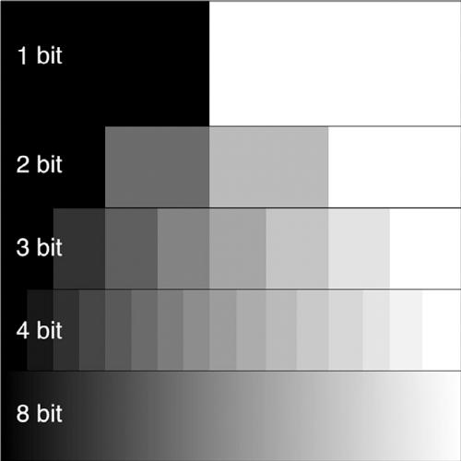

Figure 3: Representation of 256 grayscale intensity levels in an 8-bit image.

F. Discuss the effect of quantization on image quality, storage size, and intensity accuracy.

Ans: Quantization affects the image in three main ways:
- Image Quality: Higher bit depth gives smoother and clearer images, while lower bit depth may cause loss of detail.
- Storage Size: Higher bit depth requires more memory. An 8-bit image uses 1 byte per pixel, providing a good balance between quality and storage.
- Intensity Accuracy: An 8-bit image stores 256 intensity levels (0–255), which is sufficient for most grayscale image processing applications.

Question 3: Edge Detection in Thin Line Images

Given:
- Image size = 512 × 512
- Thin white vertical and horizontal lines of 1-pixel thickness
- Dark uniform background
- Objective: Detect the thin line boundaries accurately.

- Compare Sobel, Prewitt, and Canny edge detectors for detecting 1-pixel-thick vertical and horizontal lines.

Ans: Sobel edge detector provides better noise reduction than Prewitt because it gives more weight to the center pixels. Prewitt is simple and fast but is less accurate in detecting thin edges. Canny edge detector is the best choice because it removes noise, detects weak edges, and provides accurate edge localization. Therefore, Canny is most suitable for detecting 1-pixel-thick vertical and horizontal lines.

B. For a horizontal edge located near pixel position (256, 256), compute the Sobel gradient response using the standard Sobel operator.

Ans:

The standard Sobel operators are:
Horizontal (Gx)
$$\left[\begin{matrix}-1 & 0 & 1 \\ -2 & 0 & 2 \\ -1 & 0 & 1\end{matrix}\right]$$
Vertical (Gy)
$$\left[\begin{matrix}-1 & -2 & -1 \\ 0 & 0 & 0 \\ 1 & 2 & 1\end{matrix}\right]$$
For a horizontal edge,
- Gx = 0
- Gy = 1020
Gradient magnitude,
$$G=\sqrt{G_{x}^{2}+G_{y}^{2}} \\ =\sqrt{0^{2}+{1020}^{2}} \\ G=1020$$
Therefore, the Sobel gradient response is 1020.

C. Explain how the gradient magnitude and gradient direction help in identifying the strength and orientation of an edge.

Ans: The gradient magnitude indicates the strength of an edge. A larger gradient value means a stronger edge. The gradient direction indicates the orientation of the edge, such as horizontal, vertical, or diagonal. These two values help detect the exact location and direction of image edges.

D. Discuss the role of Gaussian smoothing in the Canny edge detection process.

Ans: Gaussian smoothing is used before edge detection to remove image noise. It smooths small intensity variations and reduces unwanted edges. This helps the Canny edge detector produce more accurate and cleaner edge results.

E. Explain how Gaussian smoothing may affect edge localization, especially for thin lines.

Ans: Gaussian smoothing may slightly blur very thin lines. Because of this, the exact position of the edge may shift slightly, reducing edge localization accuracy. Therefore, a small Gaussian filter is preferred when detecting thin lines.

F. If the Canny threshold is reduced to half of its original value, explain the expected changes in detected edges, weak edges, and false edges.

Ans: Reducing the Canny threshold increases the number of detected edges. More weak edges become visible, but noise may also be detected as edges. As a result, the image contains more false edges and unwanted edge information.

Question 4: Feature Extraction for Handwritten Digit Recognition Scenario:

Given:
- Application: Handwritten digit recognition
- Digits vary in size, rotation, stroke thickness, and writing style.
- Objective: Extract robust features before classification.

- Explain the working principles of SIFT, SURF, and ORB feature extraction methods.
Ans:
- SIFT (Scale-Invariant Feature Transform) detects important keypoints and creates descriptors that are invariant to scale and rotation.
- SURF (Speeded-Up Robust Features) works similarly to SIFT but uses a faster algorithm, making it suitable for quicker feature extraction.
- ORB (Oriented FAST and Rotated BRIEF) combines FAST keypoint detection with BRIEF descriptors. It is fast, efficient, and widely used in real-time computer vision applications.

B.Compare SIFT, SURF, and ORB in terms of scale invariance, rotation invariance, computational cost, and real-time suitability.

Feature | SIFT | SURF | ORB
Scale Invariance | Yes | Yes | Partial
Rotation Invariance | Yes | Yes | Yes
Computational Cost | High | Medium | Low
Real-Time Suitability | No | Moderate | Yes
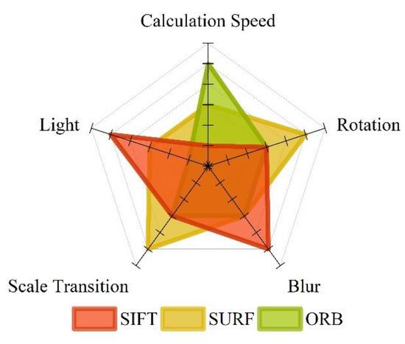
Ans: ORB is the best choice for real-time applications because it is fast and requires less computation.

Figure 1: (After part b) Comparison of SIFT, SURF, and ORB feature extraction methods.

C. If a digit image is rotated by 45 degrees, identify which feature extraction methods can still produce reliable matching features.

Ans: Both SIFT and SURF can detect reliable matching features because they are rotation invariant. ORB also supports rotation invariance and can match features correctly in most cases.

D. If the average number of keypoints detected per image is 120 and 50 images are processed, compute the total number of keypoints detected.

Ans:
Average keypoints per image = 120
Number of images = 50
Total keypoints
= 120 × 50
= 6000
Answer: 6000 keypoints

E. Suggest a suitable dimensionality reduction technique to reduce the feature size while retaining 95% of the useful information.

Ans:
A suitable technique is Principal Component Analysis (PCA). PCA reduces the number of features while preserving about 95% of the important information, making the data easier to process.
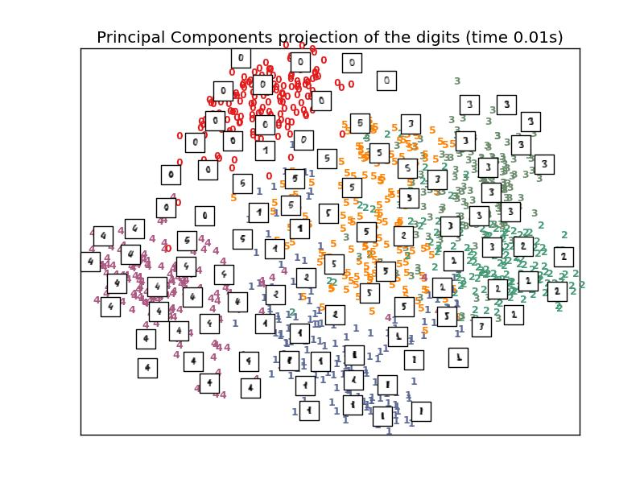
Figure 2: (After part e) PCA reducing high-dimensional features into lower dimensions while retaining important information.

F. Explain how dimensionality reduction improves classification efficiency in handwritten digit recognition.

Ans: Dimensionality reduction removes unnecessary features and keeps only the important ones. This reduces memory usage, speeds up training and testing, and improves the overall performance of the classifier.

Question 5: Morphological Preprocessing for Character Recognition Scenario:
Given:
- Image size = 256 × 256
- Binary image containing handwritten characters
- Small white noise dots in the background
- Small black gaps inside character strokes
- Objective: Clean the image before character recognition.
A. Identify the morphological operation suitable for removing small white noise dots from the background.
Ans: The Opening operation is used to remove small white noise dots from the background. It removes unwanted white pixels while preserving the shape of the characters.
B. Identify the morphological operation suitable for filling small gaps or holes inside the character strokes.
Ans: The Closing operation is used to fill small gaps and holes inside the character strokes. It connects broken parts and makes the characters more complete.
C. Explain the difference between opening and closing operations using simple image processing terminology.
Ans:
- Opening removes small white objects or noise from the image.
- Closing fills small holes and gaps inside the objects.
In simple words, opening cleans the background, while closing repairs the characters.

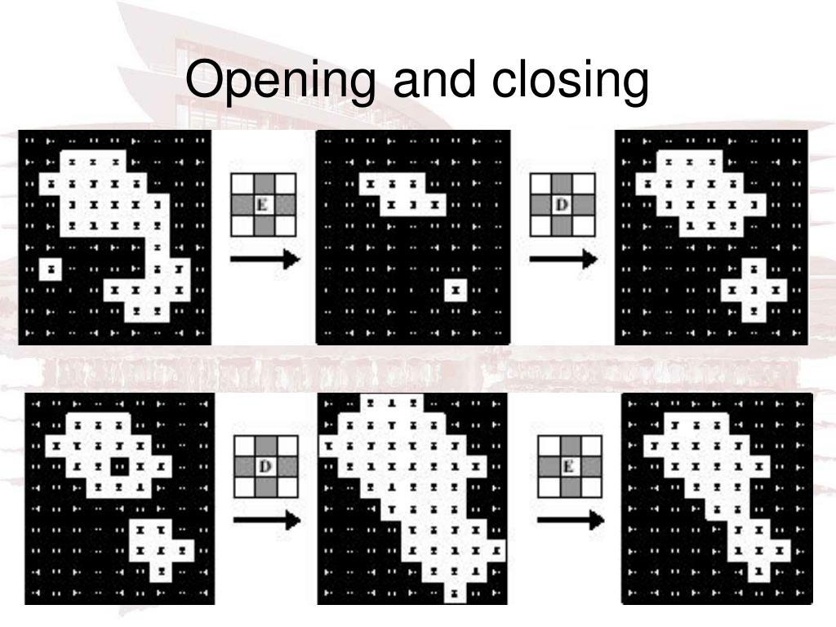
Figure 1: (After part c) Morphological Opening and Closing operations on a binary image.
D. If a 3 × 3 square structuring element is used, explain how it affects thin character strokes.
Ans: A 3 × 3 square structuring element removes small noise and fills tiny gaps. However, it may slightly thin or smooth very fine character strokes if applied repeatedly.
E. Discuss the risk of using a large structuring element during preprocessing.
Ans: A large structuring element may remove important character details, merge nearby characters, and distort their original shape. This can reduce the accuracy of character recognition.
F. Propose a complete preprocessing pipeline for handwritten character recognition, starting from image acquisition to feature extraction.
Ans:
The preprocessing pipeline is:
Image Acquisition → Grayscale Conversion → Binary Thresholding → Opening → Closing → Noise Removal → Feature Extraction
This sequence produces a clean image and improves the accuracy of handwritten character recognition.
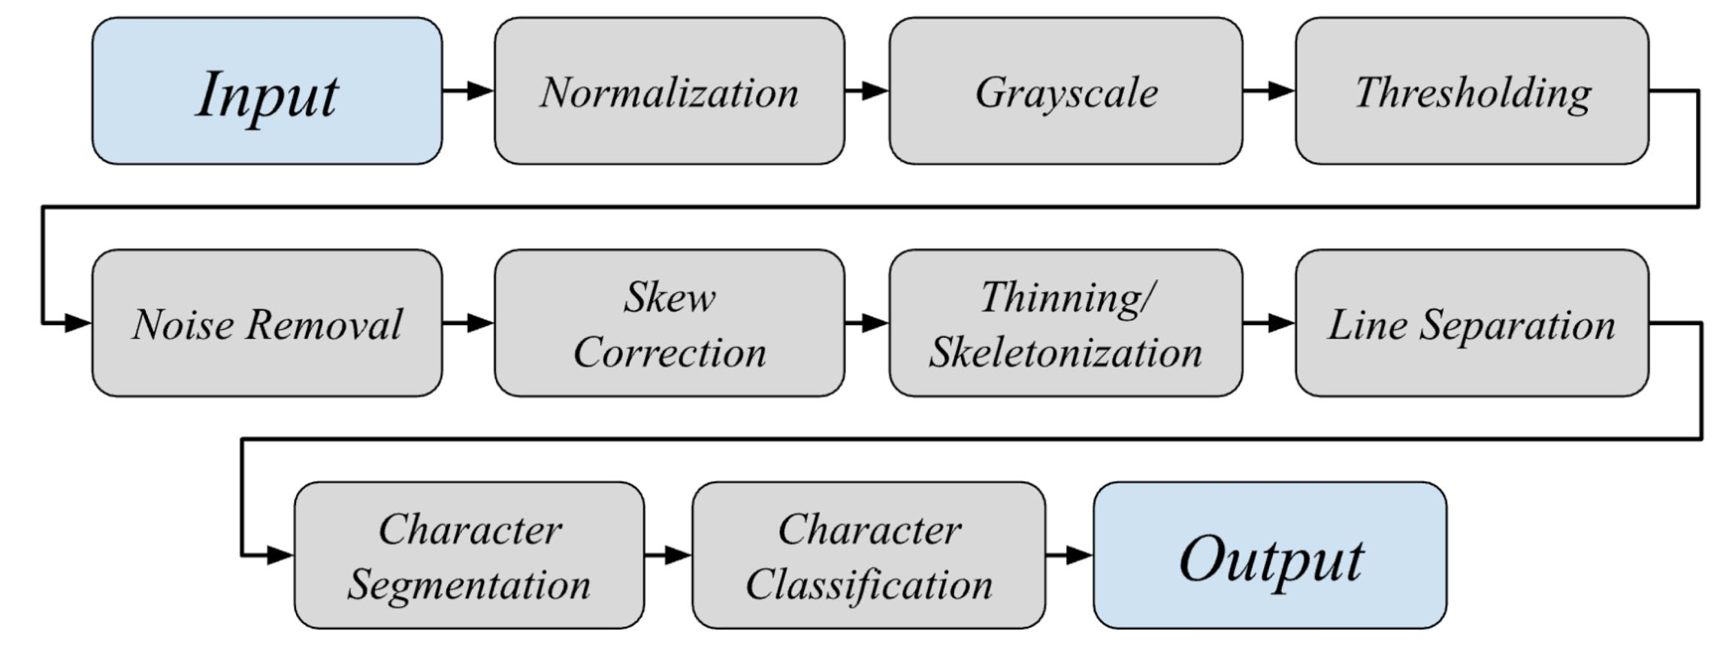

Figure 2: (After part f, before the conclusion) Handwritten character recognition preprocessing pipeline.

